1. Library Management System
Aim: To design a library website for searching books, managing users, issuing books, and calculating fines.
Algorithm:
- Start the application and display the home page.
- Allow users and librarians to log in or register.
- Display the available books and provide a search option.
- Allow librarians to add, update, or delete books.
- Enable users to view borrowing history and fines.
- Display the required book details and status.
Program:
<!DOCTYPE html>
<html lang="en">
<head>
<meta charset="UTF-8">
<meta name="viewport" content="width=device-width, initial-scale=1.0">
<title>Library Management System</title>
</head>
<body
>
<header>
<h1 align="center">Library Management System</h1>
<hr>
<nav align="center">
<a href="#home">Home</a> |
<a href="#admin">Admin</a> |
<a href="#user">User</a> |
<a href="#contact">Contact</a>
</nav>
<hr>
</header>
<section id="home">
<h2>Welcome</h2>
<p>
The Library Management System helps students and librarians manage
books, issue and return books, check fines, and download study
materials efficiently.
</p>
</section>

<hr>

<!-- Admin Section -->
<section id="admin">
<h2>Librarian Admin</h2>

<h3>Admin Login</h3>

<form>
Username:<br>
<input type="text"><br><br>

Password:<br>
<input type="password"><br><br>

<input type="submit" value="Login">
</form>
<h3>Add Book</h3>
<form>

Book Name:<br>
<input type="text"><br><br>

Author:<br>
<input type="text"><br><br>

Category:<br>
<input type="text"><br><br>
Quantity:<br>
<input type="number"><br><br>

<input type="submit" value="Add Book">

</form>

<h3>Update / Delete Book</h3>

<table border="1" cellpadding="8">
<tr>
<th>Book ID</th>
<th>Book Name</th>
<th>Author</th>
<th>Action</th>
</tr>

<tr>
<td>101</td>
<td>Java Programming</td>
<td>James Gosling</td>
<td>
<button>Update</button>
<button>Delete</button>
</td>
</tr>
</table>

<h3>Issue Book</h3>

<form>

Student ID:<br>
<input type="text"><br><br>

Book ID:<br>
<input type="text"><br><br>

Issue Date:<br>
<input type="date"><br><br>

Return Date:<br>
<input type="date"><br><br>

<input type="submit" value="Issue Book">

</form>

<h3>Return Book</h3>

<form>

Student ID:<br>
<input type="text"><br><br>

Book ID:<br>
<input type="text"><br><br>

Return Date:<br>
<input type="date"><br><br>

<input type="submit" value="Return Book">

</form>

<h3>Fine Management</h3>

<form>

Student ID:<br>
<input type="text"><br><br>

Fine Amount:<br>
<input type="number"><br><br>

<input type="submit" value="Save Fine">

</form>

<h3>Upload Study Material</h3>

<form>

Year:<br>
<select>
<option>1st Year</option>
<option>2nd Year</option>
<option>3rd Year</option>
<option>4th Year</option>
</select>

<br><br>

Semester:<br>
<select>
<option>Semester 1</option>
<option>Semester 2</option>
<option>Semester 3</option>
<option>Semester 4</option>
<option>Semester 5</option>
<option>Semester 6</option>
<option>Semester 7</option>
<option>Semester 8</option>
</select>

<br><br>

File:<br>
<input type="file">

<br><br>

<input type="submit" value="Upload">

</form>

</section>

<hr>

<!-- User Section -->
<section id="user">

<h2>User</h2>

<h3>User Login</h3>

<form>

Email:<br>
<input type="email"><br><br>

Password:<br>
<input type="password"><br><br>

<input type="submit" value="Login">

</form>

<h3>Register</h3>

<form>

Name:<br>
<input type="text"><br><br>

Email:<br>
<input type="email"><br><br>

Phone:<br>
<input type="text"><br><br>

Password:<br>
<input type="password"><br><br>

<input type="submit" value="Register">

</form>

<h3>Search Book</h3>

<input type="text" placeholder="Search Book">

<button>Search</button>

<h3>Book Details</h3>

<table border="1" cellpadding="8">

<tr>

<th>Book Name</th>

<th>Author</th>

<th>Status</th>

</tr>

<tr>

<td>Java Programming</td>

<td>James Gosling</td>

<td>Available</td>

</tr>

</table>

<h3>My Borrow History</h3>

<table border="1" cellpadding="8">

<tr>

<th>Book</th>

<th>Issue Date</th>

<th>Expiry Date</th>

</tr>

<tr>

<td>Java Programming</td>

<td>10-07-2026</td>

<td>20-07-2026</td>

</tr>

</table>

<h3>Check Fine</h3>

<p><strong>Total Fine:</strong> ₹100</p>

<h3>Study Materials</h3>

<select>

<option>Select Year</option>

<option>1st Year</option>

<option>2nd Year</option>

<option>3rd Year</option>

<option>4th Year</option>

</select>

<select>

<option>Select Semester</option>

<option>Semester 1</option>

<option>Semester 2</option>

<option>Semester 3</option>

<option>Semester 4</option>

<option>Semester 5</option>

<option>Semester 6</option>

<option>Semester 7</option>

<option>Semester 8</option>

</select>

<button>Search</button>

<p>Database Management System Notes</p>

<button>Download</button>

<h3>My Profile</h3>

<p>Name : Student Name</p>

<p>Email : student@gmail.com</p>

<p>Department : Computer Science</p>

</section>

<hr>

<!-- Contact -->
<section id="contact">

<h2>Contact Us</h2>

<form>

Name:<br>
<input type="text"><br><br>

Email:<br>
<input type="email"><br><br>

Message:<br>

<textarea rows="5" cols="40"></textarea>

<br><br>

<input type="submit" value="Send">

</form>

</section>

<hr>

<footer align="center">
<p>&copy; 2026 Library Management System. All Rights Reserved.</p>
</footer>

</body>
</html>
Result: Thus, the Library Management System website was designed to manage books and user records.

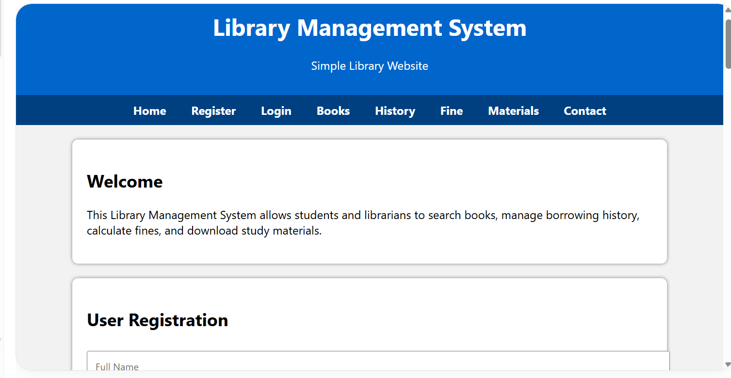
Output: 